Billsoft test report :
- Mahesh Lakhe
25/03/2026
TC – 01 : https://billsoft.agbitsolutions.com/dashboard
validation missing : street address or area > field need input validations .
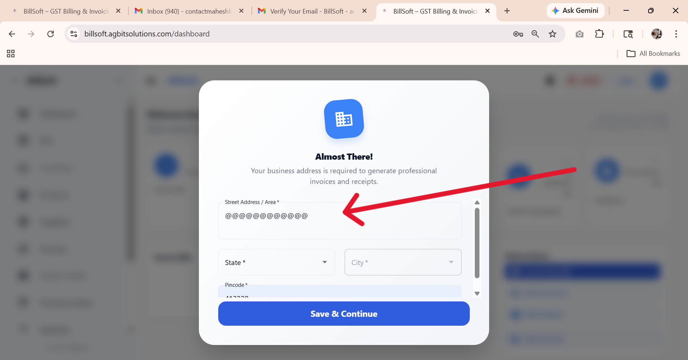

TC: 02 – https://billsoft.agbitsolutions.com/settings

Adjust Logo on Bill
Logo Size (Width)75px
Horizontal Position (X Offset)200px
Vertical Position (Offset)18px
: I use this feature I don’t see any change on logo or on uploaded image.

*is real need this feature ? lets think about it:
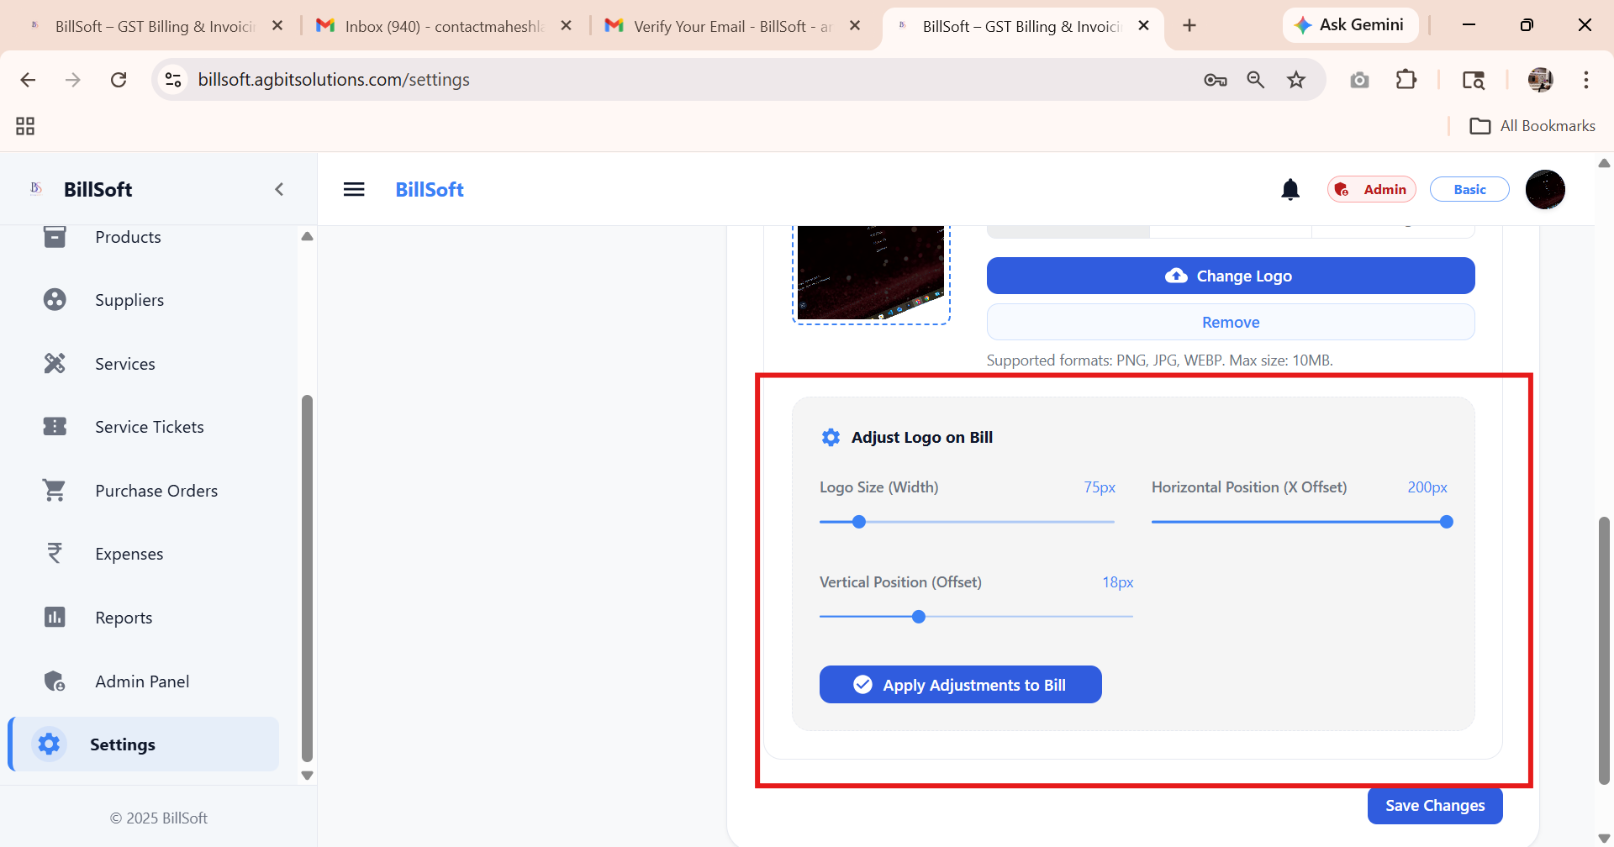

TC: 03 - https://billsoft.agbitsolutions.com/products

In this products dashboard : pagination not working :
: when user click 10 it need to change product page or else change product :
: when I click on 10 , 20 ,50 – I don’t see any change on this page :
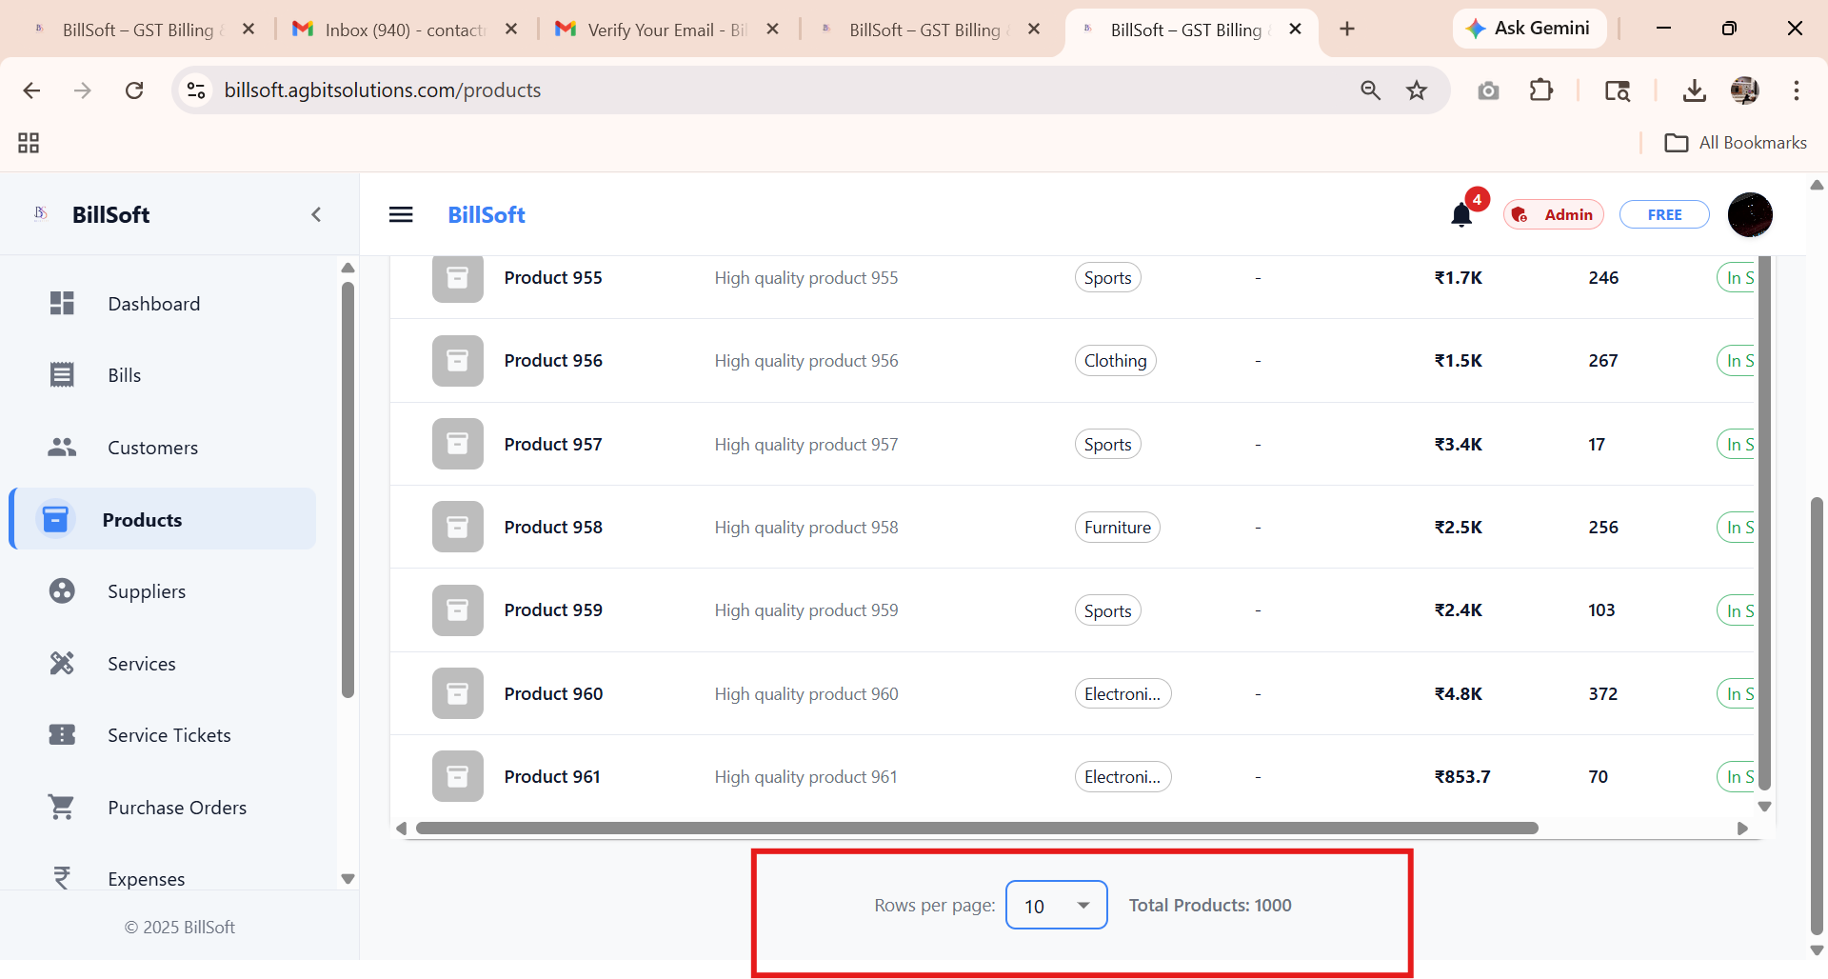

TC : 04 – https://billsoft.agbitsolutions.com/products

Configure Product Columns >Add New Column
: I don’t able to add new column
: I don’t get any error msg :

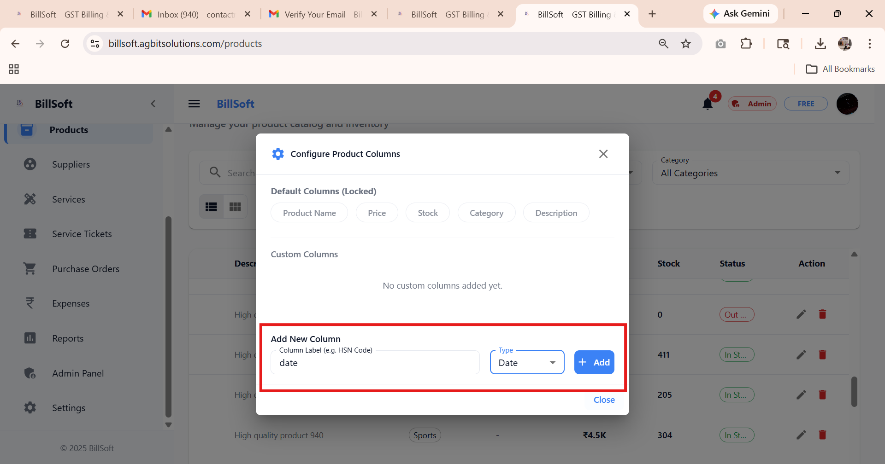

TC : 05 - https://billsoft.agbitsolutions.com/products
Add product form :

Custome field and add field :
: this two button or field don’t able to use
: when user can add according them requird add new field is not able
: for example : on mobile we need specifie the color or need to add : in product info :
So right now we only give the field no use :
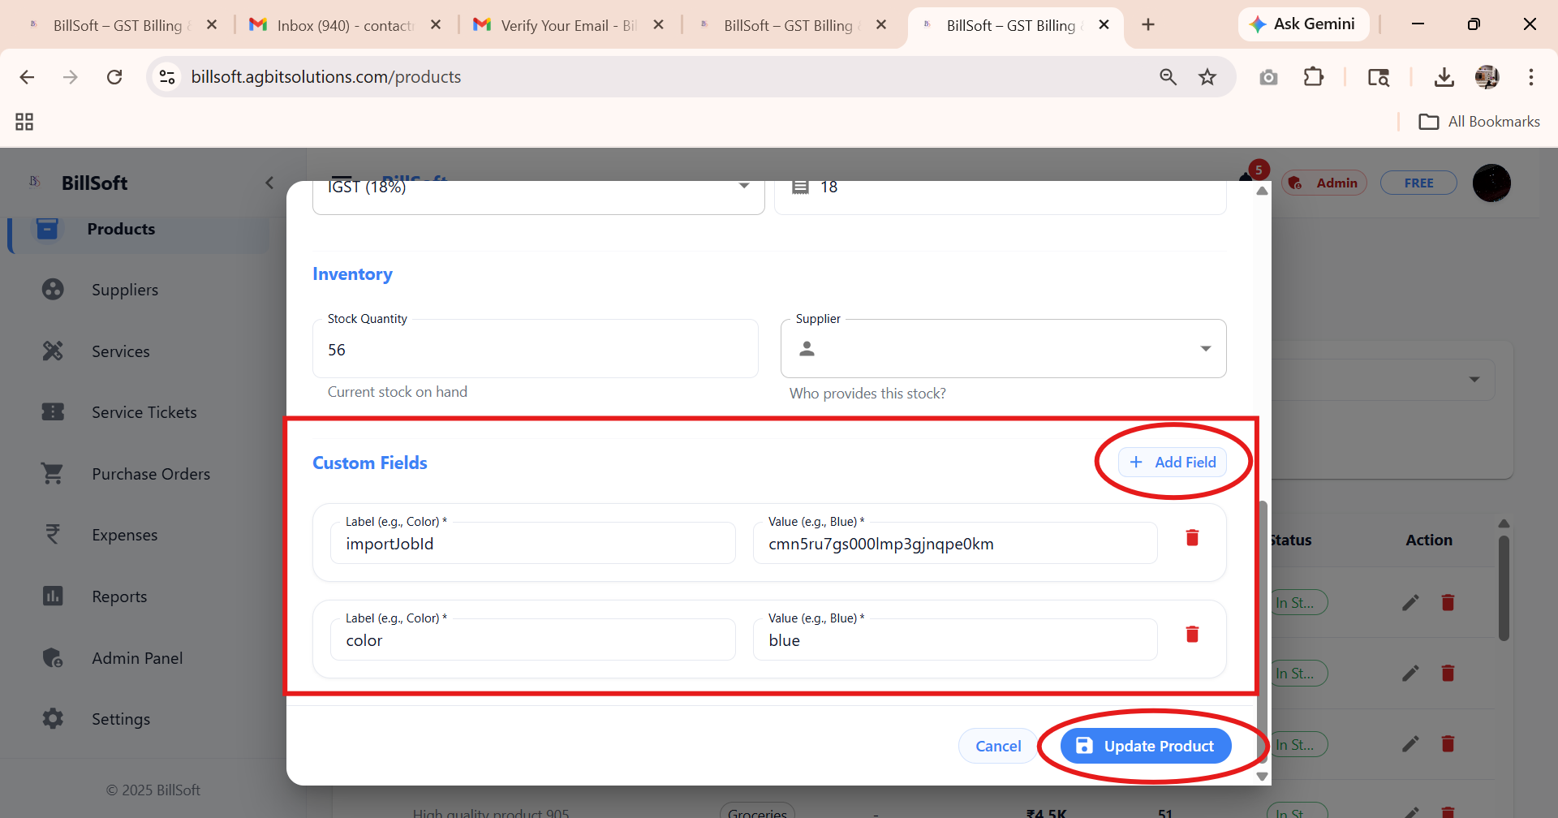

TC : 06 - https://billsoft.agbitsolutions.com/customers

Now on customer form :
Status > choose on two option – active , inactive

Inactive > it show active costumer :
need prepare filtering required :
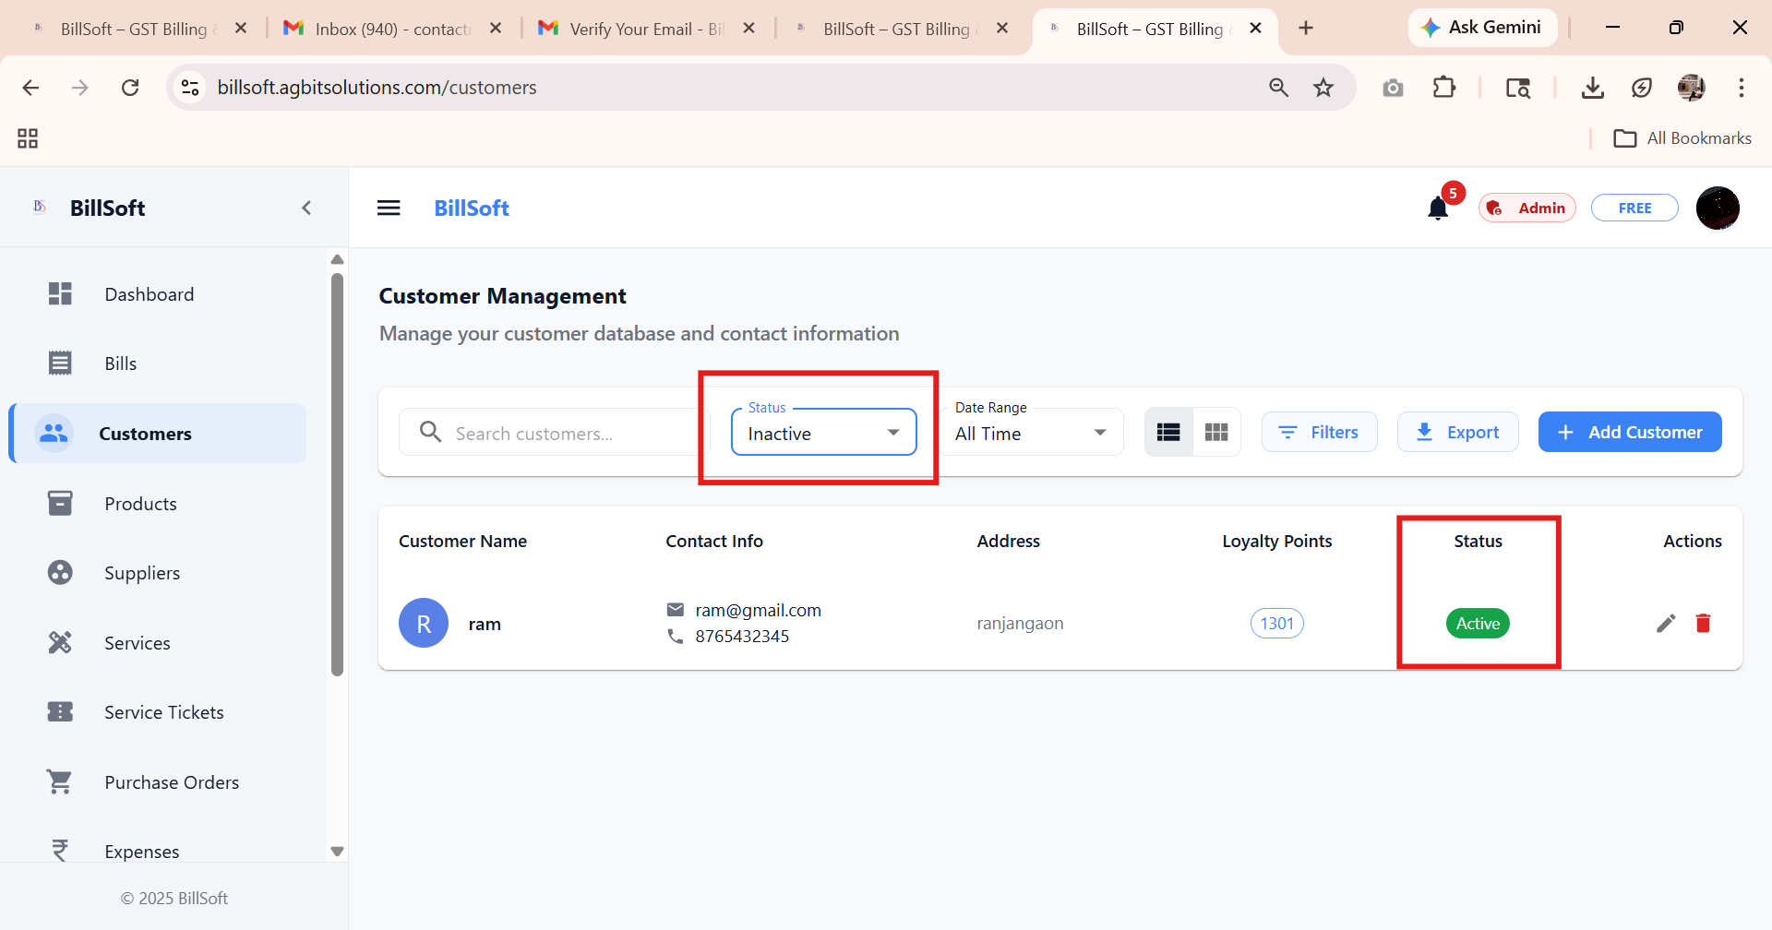

TC: 07 – https://billsoft.agbitsolutions.com/customers
Customer Management :dashboard :
In mobile view add costumer button look like broken

: need propare size .
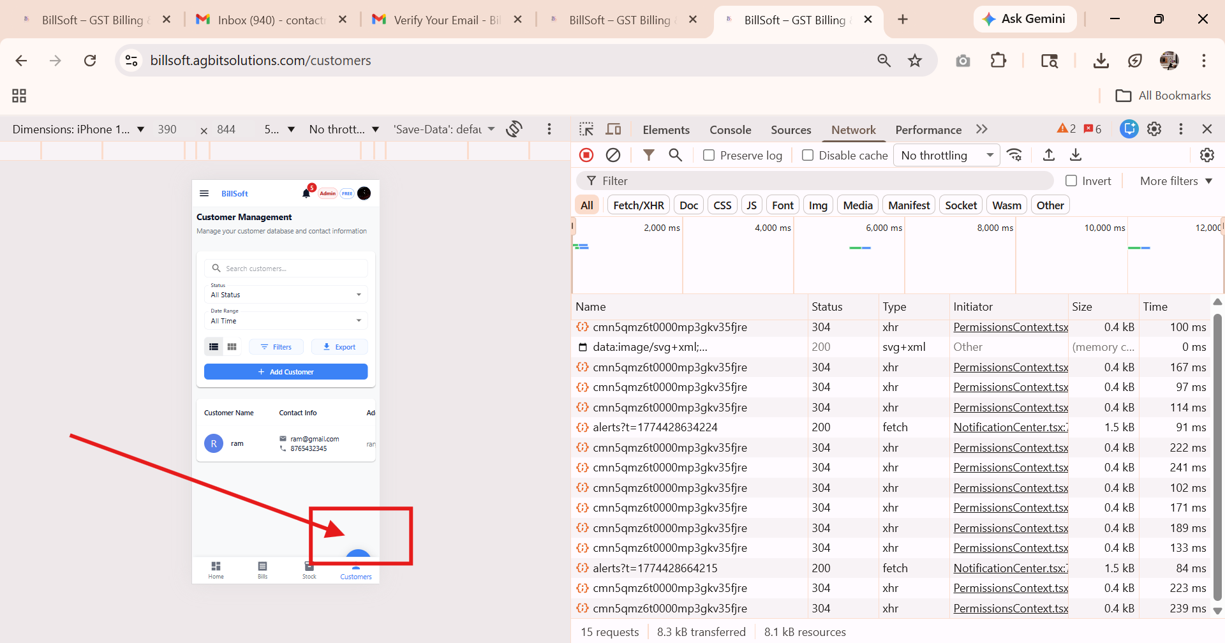

TC : 08 :
https://billsoft.agbitsolutions.com/bills/view/cmn5rdbbp000emp3g44t19ysx

in bill : when I create and see the it need fixing :
name field not in right place :
: logo is not their {in setting is on also not showing logo}

*template designing need improvement.

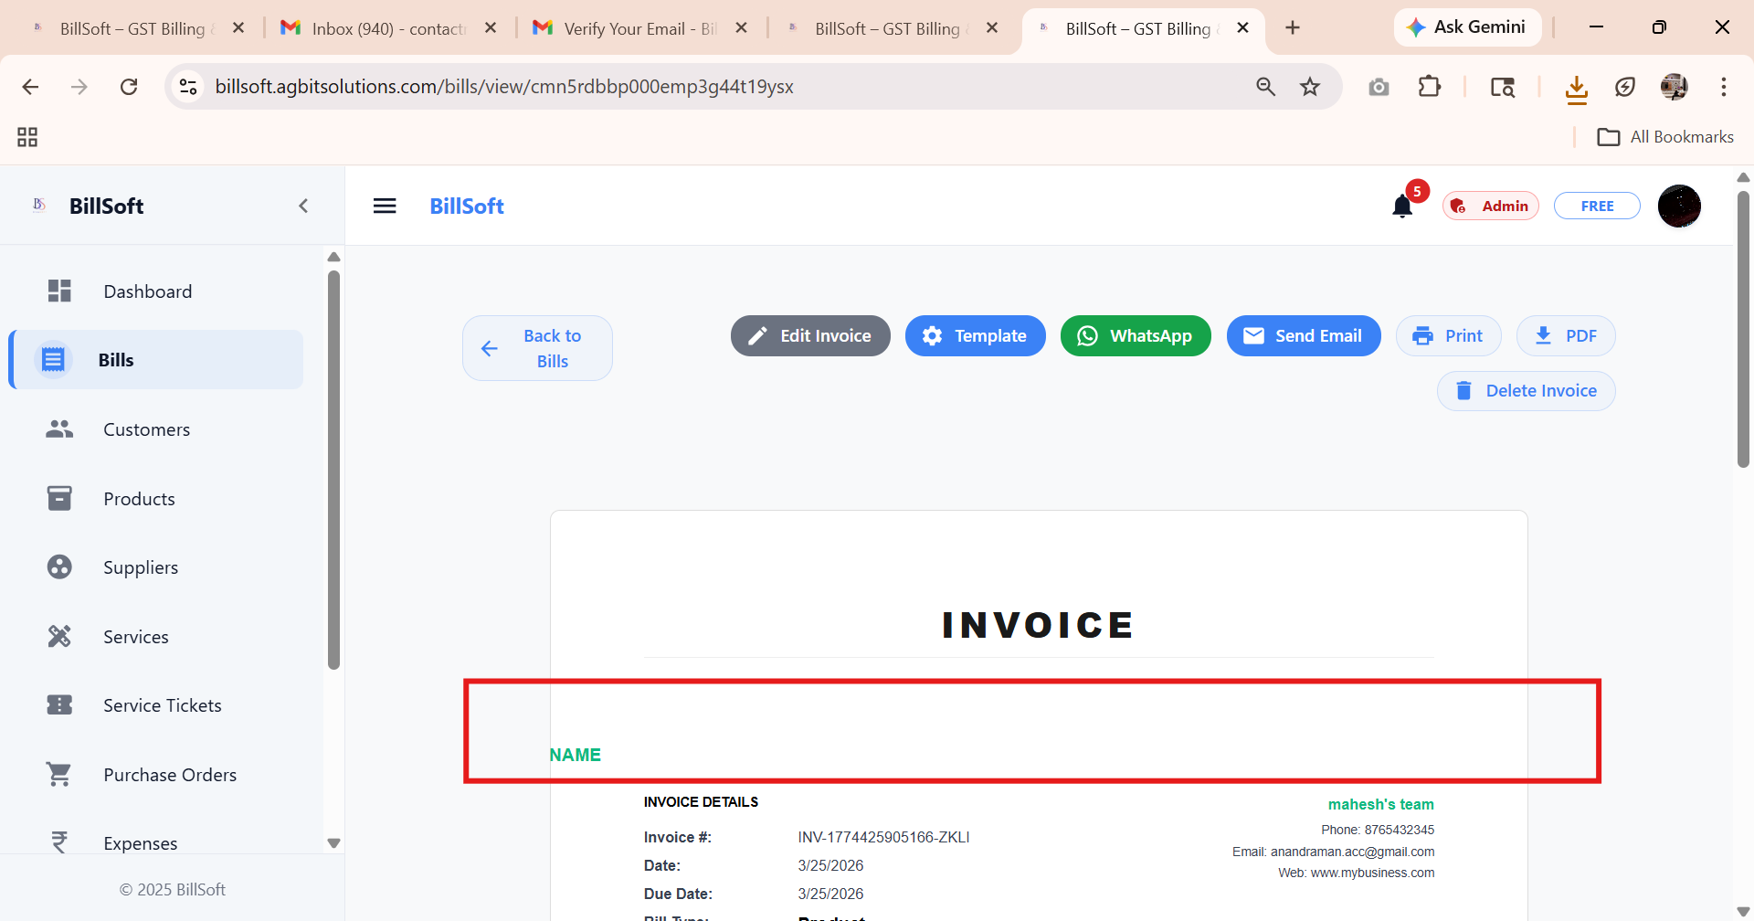

TC : 09 - https://billsoft.agbitsolutions.com/bills
: edit bill -
When try to add more product in bill :

It give 500 error. Request failed with status code 500

: user can easily update bill regenerate bill .
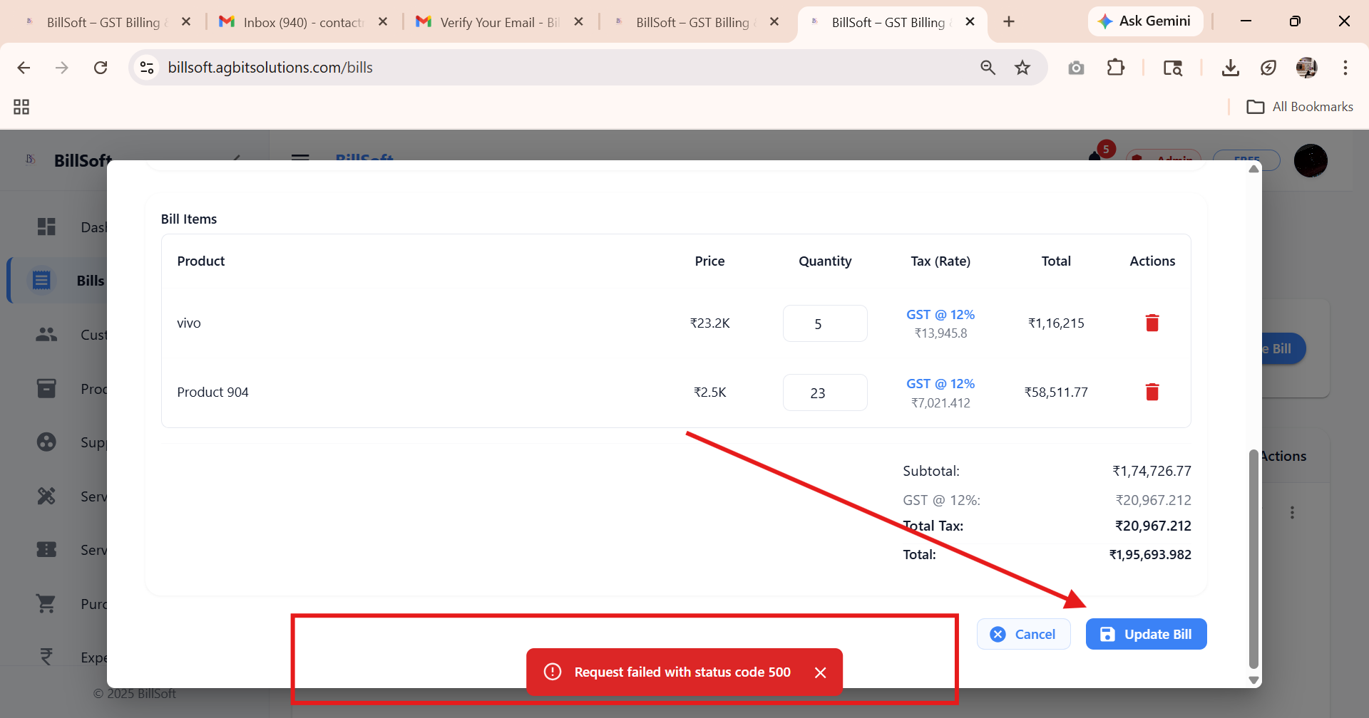

TC: 10 – https://billsoft.agbitsolutions.com/customers

In costumer form : email id field not added validation :
Test : user can add any thing which is not basically mail format

Like : 23@gmail.com

